Congratulations, you’ve made the first cut. it's proven that you're special.

Well, you need to be. you will be joining one of the most passionate and talented teams in the Indian startup ecosystem. We are excited with the prospect of having you aboard. However, we need to evaluate your skills and get an idea of how you might go about solving a problem, and how beautifully.

Assignment:

Your task is to develop a single-screen seat finder application using the Flutter framework. This app should assist users in identifying the location and type of berth based on a given seat number. In Indian trains, there are five different types of berths: Lower, Middle, Upper, Side Lower, and Side Upper.

Here is a bare minimum example of how the app must appear and work, but we encourage you to incorporate additional features that you believe would enhance its functionality.

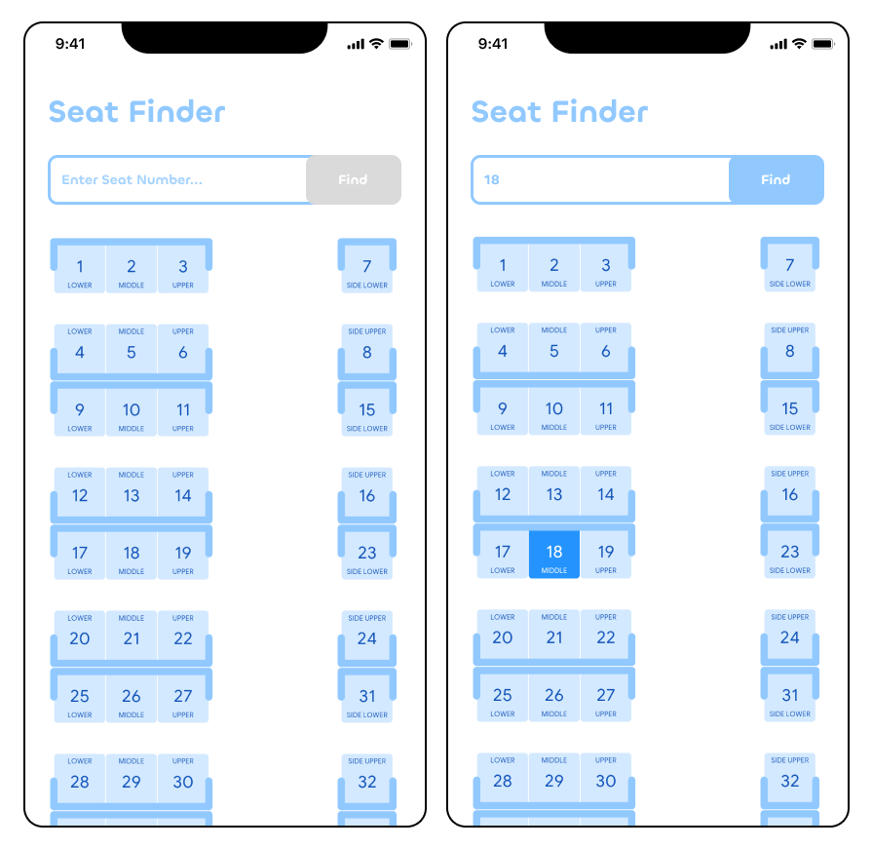

Evaluation Criteria:

Your code will be evaluated based on the following criteria:

Code Quality: We will assess the overall quality of your codebase, including its readability, maintainability, and adherence to coding best practices. Well-structured and well-documented code will be highly appreciated.

Modularity: We expect your code to be modular, with clear separation of concerns. This means breaking down the application into reusable components, functions, or classes that promote code reusability and maintainability.

Responsive UI Practices: The user interface of your app should be responsive and intuitive. We will evaluate how well you have implemented Flutter's UI framework to create a seamless and visually appealing experience for the users.

Logic Efficiency: The efficiency of your code's logic will be assessed. This includes evaluating how you handle data retrieval, manipulation, and storage, as well as any algorithms or data structures you employ. Efficient logic ensures smooth and optimised performance.

Approach Explanation: During the follow-up call, we will discuss your approach to solving the problem. We expect you to provide a clear and concise explanation of the decisions you made throughout the development process, including any trade-offs or considerations you took into account.

Submission:

The code must be submitted to a Github repository that includes a Readme file describing the methodology used and instructions on how to run the code along with a screen recording of your app in action, demonstrating how all edge cases have been handled and additional features like auto-scroll, tap to select or any additional screens you might have added. and send links to both, github repo and the video to rohan@cruv.org.

Good things take time but good things also need to get done within a limited time frame. There are no strict deadlines for this assignment but to give us enough time to evaluate and start your onboarding process, please make sure that you send it within 7 days.

If you have any further questions or need clarification, please feel free to direct it to us.

Lastly, we wish you all the best and hope to talk with you soon.

Regards,

Team CRUV.